Mini Project Report
Design and Implementation of Academic Analytics using Data Mining

Abstract
This project focuses on analyzing student performance using data mining and visualization techniques. A dataset containing academic, behavioral, and socio-economic factors such as study hours, attendance, motivation level, and family background was used. Data preprocessing techniques like handling missing values, removing duplicates, and encoding categorical variables were applied to improve data quality. Statistical analysis including mean, median, standard deviation, and Z-score was performed. Various supervised learning algorithms such as Logistic Regression, Decision Tree, and Random Forest were implemented to predict student performance. Power BI was used for visualization. The project helps identify key factors affecting academic performance.

1. Introduction
This project uses data mining techniques to analyze student performance based on various influencing factors.

2. Motivation
To understand factors affecting student performance and support data-driven decision-making.

3. Problem Definition
Analyze multiple factors influencing academic performance and predict outcomes.

4. Objectives
- Data preprocessing
- Statistical analysis
- Visualization
- Insight generation

5. Tools Used
Python, Pandas, NumPy, Matplotlib, Power BI

6. Dataset Description
Dataset includes features like study hours, attendance, motivation, family income, and exam score.

7. Data Preprocessing
Handled missing values, removed duplicates, encoded categorical data, calculated statistics and Z-score.

8. System Architecture
Data Source  (CSV) | ETL Process  (Cleaning & Transformation) | Analysis & Visualization  (ML + Power BI)

9. Data Mining Tasks
Classification, correlation analysis, and visualization.

10. Algorithms
Logistic Regression, Decision Tree, Random Forest

11. Output
Predictions, accuracy metrics, confusion matrix, and insights.

12. Visualization Screenshots
Figure 1: Average Exam Score by Gender
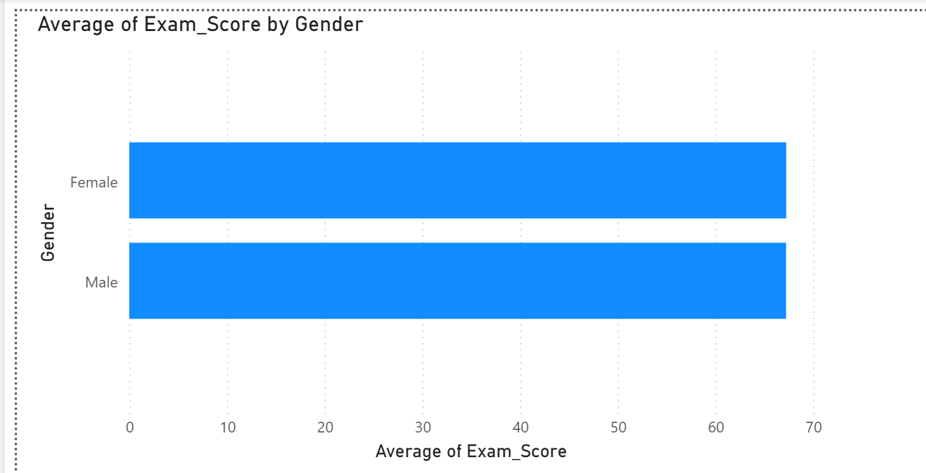
Figure 2: Motivation Level Distribution
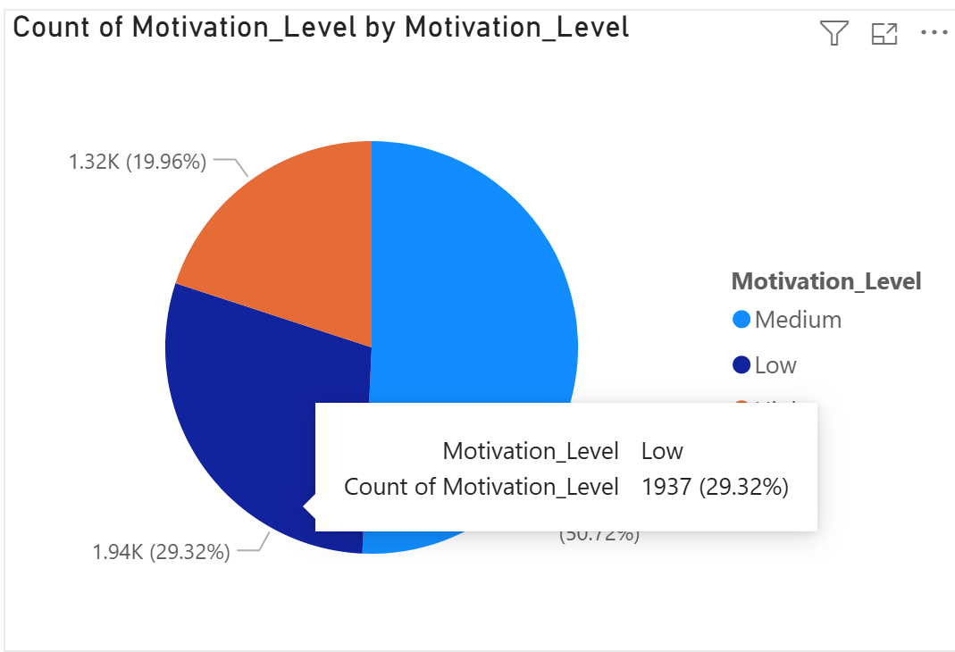

13. Conclusion
The project demonstrates the use of data mining to analyze and predict student performance.

14. References
[1] Data Mining Concepts and Techniques
[2] Power BI Docs
[3] Kaggle Dataset

